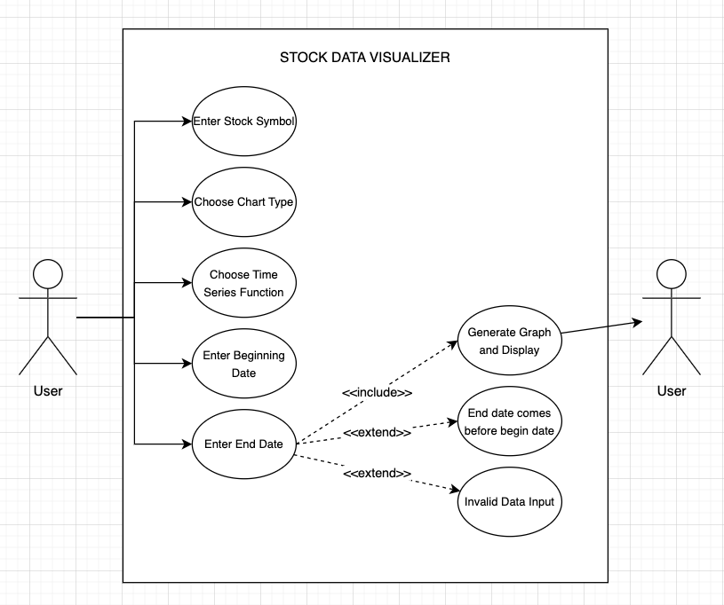

DESCRIPTIONS

**Enter Stock Symbol:**

* Primary Actor:
  + User
* Preconditions:
  + The stock data visualizer is running.
* Postconditions:
  + The stock symbol is stored.
  + The user is asked to choose a chart type.
* Triggers:
  + The user runs the Stock Data Visualizer program
* Basic Flow:
  + The user enters a stock symbol.
  + The system stores the stock symbol.
* Termination Outcomes:
  + The stock symbol is valid.
  + The stock symbol is invalid.
* Alternative Paths:
  + If the user enters an invalid stock symbol then they are displayed an error message.

**Choose Chart Type:**

* Primary Actor:
  + User
* Preconditions:
  + The user has entered a stock symbol.
* Postconditions:
  + The chart type is stored for visualization.
  + The user is asked to choose a time series function.
* Triggers:
  + The stock symbol is entered by the user.
* Basic Flow:
  + The user selects a chart type.
  + The system stores selected chart type.
* Termination Outcomes:
  + The chart type is stored
  + Invalid choice of chart type
* Alternative Paths:
  + Invalid chart type

**Choose Time Series Function:**

* Primary Actor:
  + User
* Preconditions:
  + The user has entered a valid chart type
* Postconditions:
  + The time series function is stored.
  + The user is asked to enter a beginning date.
* Triggers:
  + A valid chart type is chosen
  + The user is prompted to choose a time series function.
* Basic Flow:
  + The user selects a time series function.
  + The system stores the selected time series function.
* Termination Outcomes:
  + The time series function is stored
  + The user must enter a valid time series
* Alternative Paths:
  + Invalid time series function

**Enter Beginning Date:**

* Primary Actor:
  + User
* Preconditions:
  + The user has selected a valid time series function.
* Postconditions:
  + The user is asked to enter an end date
  + Begin date is stored
* Triggers:
  + The user has selected a valid time series function.
  + The user is prompted to enter a valid end date.
* Basic Flow:
  + The user enters a begin date (YYYY-MM-DD)
  + System stores begin date.
* Termination Outcomes:
  + The beginning date is valid and stored
  + The begin date is an invalid date, and prints an error message.
* Alternative Paths:
  + The beginning date is invalid.

**Enter End Date:**

* Primary Actor: User
* Preconditions:
  + A valid beginning date was entered.
* Postconditions:
  + The user is displayed the stock data graph
* Triggers:
  + A valid beginning date is entered
  + The user is prompted to enter an end date
* Basic Flow:
  + The user is prompted to enter an end date.(YYYY-MM-DD)
  + The end date is stored.
* Termination Outcomes:
  + The end date is valid and stored.
  + The end date entered is either not in the correct format or before the beginning date.
* Alternative Paths:
  + Invalid date format
  + The end date comes before the beginning date.

**Generate Graph and Display:**

* Primary Actor: System
* Preconditions:
  + The user has entered all valid parameters.
* Postconditions:
  + A graph is generated and displayed to the user
* Triggers:
  + The system retrieves stock data based on the user inputs
* Basic Flow:
  + The system retrieves stock data
  + Generates the graph
* Termination Outcomes:
  + The graph is successfully generated
  + The data could not be retrieved
* Alternative Paths:
  + Data retrieval failure
  + Invalid input parameters.